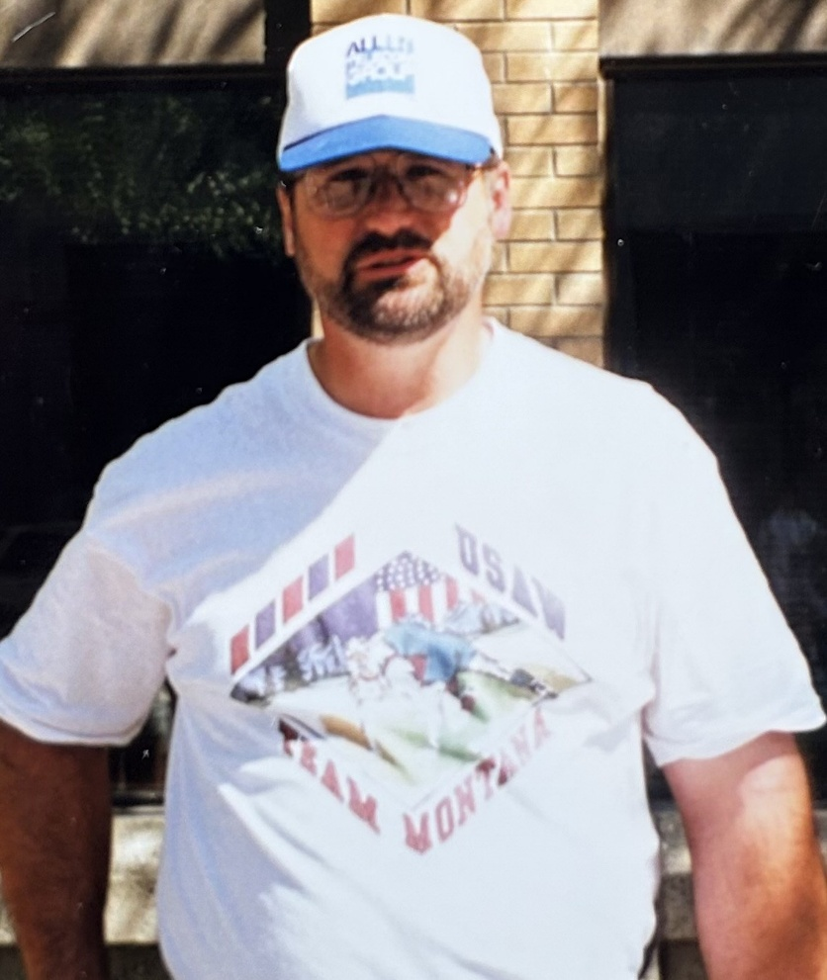

Gordon R. Smith

Gordon was born on September 19, 1956, and began coaching youth wrestling with the Butte Wrestling Club in 1984. He was dedicated and determined to provide young wrestlers an opportunity to excel both on and off the mat. As a coach, he proudly enjoyed great success by helping to lead the Butte Wrestling Club to multiple state championships and assisting young wrestlers become Regional Champions, National Champions and All-Americans. His love and commitment to the sport, assisted numerous young wrestlers achieve their goal of wrestling in college, which included three at the Division I level, where some wrestlers even earned All-American honors at the college level. Gordon’s desire to help all young wrestlers achieve success was not limited to Butte. So, in the 1990s, he was proudly selected as the President of Montana USAW, where he worked to unite clubs throughout the state to help create better opportunities for all young Montana wrestlers. Gordon continued his work as President of Montana USAW until his sudden and unexpected passing at the age of 45 on October 4, 2001.