Gene Davis Biography for the Montana Wrestling Hall of Fame https://www.olympedia.org/athletes/60607
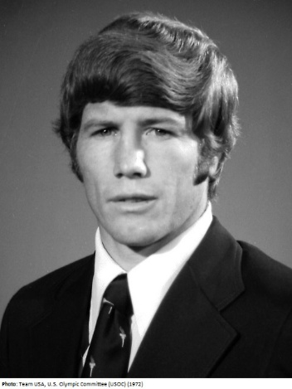
Name: Gene Davis
Date of Birth: November 17, 1945
Current Status: Present

Gene Davis is a name synonymous with excellence in the world of wrestling. His remarkable journey as a national champion, Olympic medalist, and international coach has etched his legacy into the annals of the sport. However, it is his profound impact on the lives of countless individuals through his personal ministry that truly sets him apart. For 17 years, Gene served as both a wrestler and coach with Athletes in Action, a division of the Campus Crusade for Christ. During this time, he and his colleagues utilized athletics as a platform to share their message with sports fans across the nation. While the AIA wrestlers boasted an impressive record of 188 wins out of 224 dual meets and secured two national team championships, their primary focus was always on inspiring and uplifting others. Gene’s wrestling career began in Missoula, Montana, where he achieved an incredible feat by becoming a four-time high school champion, finishing his career undefeated in 66 matches. He then took his talents to Oklahoma State University, where he became an NCAA champion and a three-time All-American with a record of 66 wins, 3 losses, and 1 tie. His outstanding performance earned him the title of Outstanding Wrestler in the Big Eight. After graduation, Gene joined Athletes in Action and continued to shine on the mat for 11 additional years. His accolades include winning four national freestyle titles and placing fourth and sixth in the World Championships. Gene's tenacity and dedication culminated in his selection to the 1972 Olympic team in Munich, where he returned in 1976 as Olympic captain, earning a bronze medal in Montreal. Gene’s commitment to his team often led him to make personal sacrifices. In pursuit of team success, he made the difficult decision to drop to 136.5 pounds for the 1976 Olympics, despite dominating the 149.5-pound class all year. This selfless act allowed another U.S. candidate a chance to compete. Although he achieved victories over reigning world champions, the strain of weight-cutting hindered his pursuit of a gold medal. In 1979, Gene's coaching prowess shone brightly as he led the United States to a clean sweep of 10 gold medals at the Pan American Games. Two years later, he served as the World team coach, further solidifying his role as a leader in the wrestling community. For his outstanding achievements and exemplification of sportsmanship and leadership, Gene Davis was honored as a Distinguished Member of the National Wrestling Hall of Fame in 1985.

Awards and Achievements:
- 1985: Distinguished Member, National Wrestling Hall of Fame
- NCAA All-American Awards:
  - 1966: Oklahoma State, Division I, 137 lbs., 1st place
  - 1967: Oklahoma State, Division I, 137 lbs., 3rd place
  - 1965: Oklahoma State, Division I, 137 lbs., 4th place
College Career Records:
- Total Bouts: 67
- Wins: 61
- Losses: 5
- Ties: 1
- Falls: 18
- Win Percentage: 91.04%

Gene Davis's legacy transcends his achievements on the mat; he is a beacon of inspiration and integrity in the sport of wrestling. His contributions to both athletics and the personal growth of others have left an indelible mark on the wrestling community in Montana and beyond.

