**Biography of Dave Edington for the Montana Wrestling Hall of Fame**

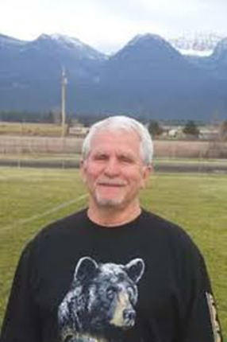

Dave Edington is a distinguished figure in the world of high school wrestling and education, celebrated for his remarkable contributions as a coach, educator, and mentor. His career commenced in the fall of 1968 in Ronan, Montana, where he made a significant impact on the sport and the lives of his students.

**Early Life and Education**Born and raised in Saratoga, Wyoming, Edington showcased exceptional talent in wrestling during his high school years. He was a four-time state champion, becoming the first in Wyoming to accomplish this feat and the second in the nation, solidifying his legacy in the sport. His achievements laid the groundwork for a future filled with accomplishments, both in the wrestling arena and as an educator.

**Coaching Career**In Ronan, Edington became the first head coach of boys’ wrestling, a position he held for an impressive 20 years. Under his leadership, his teams achieved remarkable success, producing 59 individual champions and securing eight team championships. His coaching record boasts 225 dual meet victories, ranking him seventh all-time in the Montana High School Association’s record book.

**Awards and Recognitions**Edington’s exceptional coaching abilities earned him the title of Montana Coaches’ Association Coach of the Year on seven occasions. His influence extended beyond the state level, as he was inducted into both the AAU National Wrestling Hall of Fame and the Montana Indian Hall of Fame, recognizing his contributions to the sport and the community.

**Contributions to Olympic Wrestling**In addition to his high school coaching, Edington played a significant role in the Olympic wrestling efforts in the United States. He was a member of the wrestling coaching staff in 1976 and served on the administrative hosting staff in 1984, further showcasing his dedication to the sport at a national level.

**Legacy**David Edington’s legacy as a coach and educator continues to inspire future generations of wrestlers. His passion for the sport and commitment to excellence have left an indelible mark on the wrestling community in Montana and beyond. Through his efforts, he has not only shaped champions but also instilled values of hard work, perseverance, and sportsmanship in all his students. Edington’s life on the mat was spectacular. He was more than a champion; he was a blue-collar kid who became a role model for many, demonstrating that success in wrestling could lead to a better life. As he often says, “Wrestling is the great equalizer,” a sentiment that reflects his own journey from humble beginnings to becoming a beloved figure in the community. Today, Edington continues to live in Ronan, where he has devoted more than 45 years to education and athletics. His impact on the sport and the lives of his students is a testament to the power of mentorship and dedication. The Montana Wrestling Hall of Fame honors Dave Edington not only for his unparalleled achievements on the mat but also for the legacy he has created through his commitment to the sport and his community.